1)WAF to print all the elements of an array by passing it as an argument

//WAF to print all the elements of an array by passing it as an argument
#include<iostream.h>
#include<conio.h>
#include<stdio.h>
void show(int[]);
main()
{
clrscr();
int a[3];
for(int i=0;i<3;i++)
{
cout<<"Enter number ";
cin>>a[i];
}
show(a);
getch();
}

void show(int a[3])
{
cout<<"The numbers are ";
for(int i=0;i<3;i++)
cout<<a[i]<<'\t';
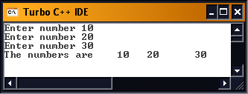
}
2) WAF to print the largest element of an array
// WAF to print the largest element of an array
#include<iostream.h>
#include<conio.h>
#include<stdio.h>
int chek(int[]);
main()
{
clrscr();
int a[3];
for(int i=0;i<3;i++)
{
cout<<"Enter number ";
cin>>a[i];
}
int res;
res=chek(a);
cout<<"The largest number is "<<res;
getch();
}

int chek(int a[3])
{
for(int i=0,max=0;i<3;i++)
{
if(a[i]>=max)
max=a[i];
}
return(max);
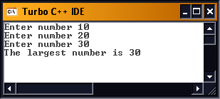
}
3) WAF to print sum of elements of an array
//3) WAF to print sum of elements of an array
#include<iostream.h>
#include<conio.h>
#include<stdio.h>
int sum(int[]);
main()
{
clrscr();
int a[3];
for(int i=0;i<3;i++)
{
cout<<"Enter number ";
cin>>a[i];
}
int res;
res=sum(a);
cout<<"The sum is "<<res;
getch();
}

int sum(int a[3])
{
for(int i=0,sum=0;i<3;i++)
sum+=a[i];
return(sum);
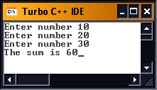
}
4) WAF to get a string and count number of vowels

// WAF to get a string and count number of vowels
#include<iostream.h>
#include<conio.h>
#include<stdio.h>
int vow(char[]);
main()
{
clrscr();
char str[20];
cout<<"Enter a string ";
gets(str);
int num;
num=vow(str);
cout<<"The number of vowels is "<<num;
getch();
}

int vow(char str[20])
{
for(int i=0,vow=0;str[i]!='\0';i++)
{
if(str[i]=='a' || str[i]=='e' || str[i]=='i' || str[i]=='o' || str[i]=='u')
++vow;
else if(str[i]=='A' || str[i]=='E' || str[i]=='I' || str[i]=='O' ||str[i]=='U')
++vow;
}
return(vow);
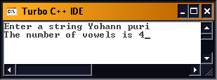
}
5) WAF to count number of words in a string passed as an argument

// WAF to count number of words in a string passed as an argument
#include<iostream.h>
#include<conio.h>
#include<stdio.h>
int word(char[]);
main()
{
clrscr();
char str[30];
cout<<"Enter a string ";
gets(str);
int num;
num=word(str);
cout<<"The number of words is "<<num+1;
getch();
}

int word(char str[20])
{
for(int len=0;str[len]!='\0';len++);
for(int i=0;str[i]!=32;i++);
for(int num=0;str[i]!='\0';i++)
{
if(str[i]==32 && str[i+1]!=32)
num++;
}
if(str[len-1]==32)
num-=1;
if(str[0]==32)
--num;
return(num);
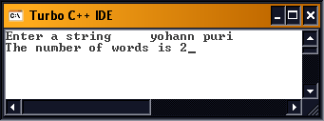
}
6) WAF to count the length of a string

// WAF to count the length of a string
#include<iostream.h>
#include<conio.h>
#include<stdio.h>
int count(char[]);
main()
{
clrscr();
char str[30];
cout<<"Enter a string ";
gets(str);
int num;
num=count(str);
cout<<"The length is "<<num;
getch();
}

int count(char str[20])
{
for(int i=0;str[i]!='\0';i++);
return(i);



